Tutorial 6 - SPM (Wk 11 done )

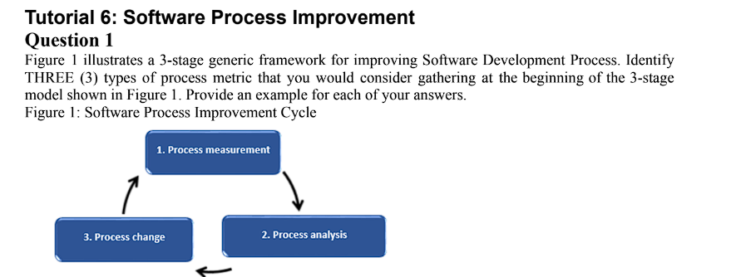

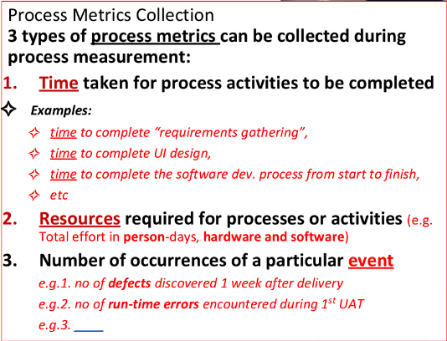
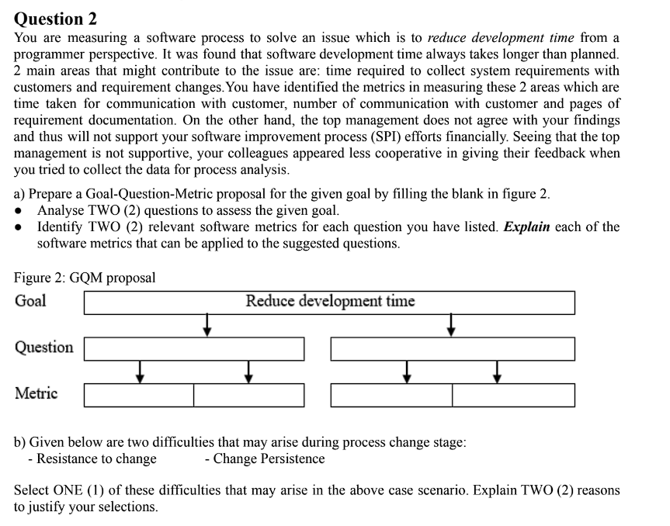
a)
Goal: Reduce development time

Question 1: How much time is required to collect system requirements from customers?
  - Requirement collection is a critical early stage. If it takes too long, the whole development is delayed. By analyzing the time and effort spent during requirement gathering, we can check if inefficiency here is a root cause of long development time.

Question 2: How often do requirement changes occur during the project?
  - Frequent requirement changes cause rework, which increases development time. Monitoring the frequency and scale of these changes helps identify if requirement instability is the main cause of delays.

Metric
For 1st question
  - Metric 1: Time taken for communication with customers
  - Metric 2: Number of communications with customers
For 2nd question
  - Metric 1: Number of requirement change requests
  - Metric 2: Number of pages/amount of updated requirement documentation

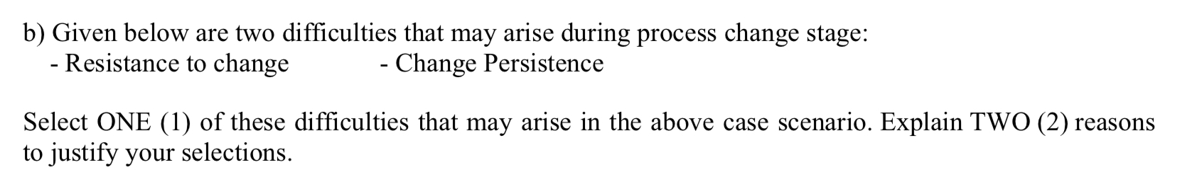b) Resistance to change

Reason 1: Fear of uncertainty and loss of comfort zone
- Employees and stakeholders are often used to existing workflows, tools, and habits. When a new process is introduced, they may fear that their current skills will become obsolete or that they will fail to adapt to the new expectations. This psychological barrier creates reluctance to accept the change, leading to slowed adoption and even hidden opposition.
Reason 2: Increased workload and training requirements
- Process changes usually require additional training, adjustment to new tools, and a temporary drop in productivity as people learn. Staff may perceive this as extra work added on top of their current responsibilities. Without clear communication of the benefits, they may resist because the short-term burden seems heavier than the long-term gain.

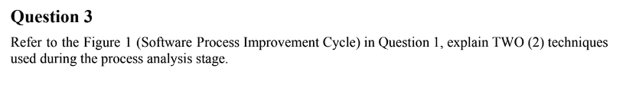
Extra Ans:
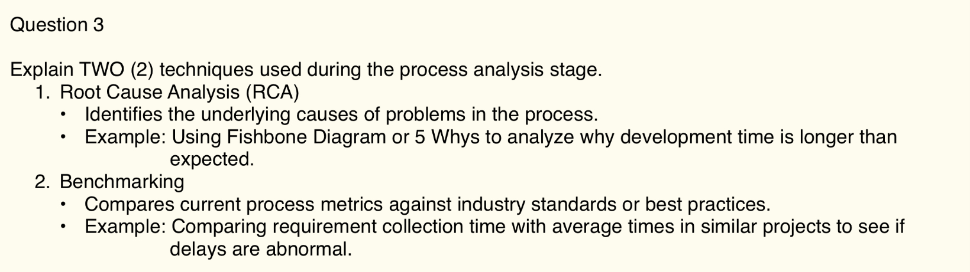
From lecture notes: